 |  | 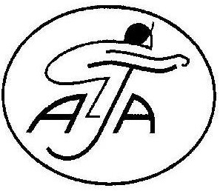

THE 2010

GREATWOOD CHARITY SWEEPSTAKE
FRIDAY 15TH OCTOBER
SUPPORTED BY THE AMATEUR JOCKEYS ASSOCIATION

R I D E R ‘ S A P P L I C A T I O N F O R M
NAME
Age |  | DATE OF BIRTH
Address
Telephone
Mobile
E-mail
Relevant details of riding career and experience, racing experience (if any), current occupation etc
Relevant race riding experience including previous charity races
(if any)
Previous fund raising experience
(if any)
Any other details - please include anything to support your application ie sponsorship plans

Signed _____________________________________ date ____________________

Print name: _________________________________

Please return this entry form as soon as possible to:

Sarah Oliver, Amateur Jockeys Association, Crews Hill House, Alfrick, Worcester. WR6 5HF Tel: 01886 884488 Fax: 01886 884068 e-mail: sph.oliver@binternet.com

